Recruiting Strong Advocates for DD Council Membership

June 11, 2021

The Louisiana Developmental Disabilities Council is currently recruiting applicants STATEWIDE to fill multiple membership vacancies.

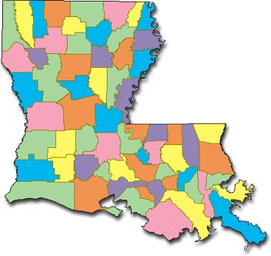

Are you or someone you know interested in improving the system of supports for people with developmental disabilities and their families? Do you support the self-determination, independence, productivity, and full inclusion of people with developmental disabilities in all facets of community life? If so, please consider applying for membership on the Louisiana Developmental Disabilities Council!

Applicants must be one of the following:
- An individual with a developmental disability;
- A parent or guardian of a child with a developmental disability; or
- The immediate relative or guardian of an adult with an intellectual developmental disability who cannot advocate for themselves.

To apply for Council membership, please click here. The deadline for receiving applications in order to be considered for one of three positions is July 11, 2021. Although you may complete and submit your application electronically, if you choose to download and mail in your application, it must be received no later than July 11, 2021.

Council members are appointed by the Governor and generally serve four-year terms. When a vacancy exists, a membership committee of the Council reviews all applications received throughout the year and makes recommendations to the full Council for approval. Council- approved recommendations are submitted to the Governor for consideration.

The Developmental Disabilities Assistance and Bill of Rights Act includes criteria for states to follow in selecting their Council’s membership (including the definition of developmental disabilities). The Louisiana Council assures its membership complies with federal law.

Persons of all races, ethnicity, religion, gender, orientation, national origin, age, and type of developmental disability meeting one of the criteria mentioned above are highly encouraged to apply. Please share this information and help others become aware of this opportunity to serve their community.

More information about the Council can be found on our website.

Contact Us
LaDDC News is the electronic newsletter for the LA Developmental Disabilities Council. If there are any questions about the information above, contact the Council by replying to this email, or calling the toll-free number listed below.
phone: 1(800)450-8108
email: info@laddc.org website: www.laddc.org
facebook: www.facebook.com/LaDDCouncil twitter: www.twitter.com/LaDDCouncil
Sign up to receive LaDDC Newsletters HERE. View all recent LaDDC Newsletters HERE.

